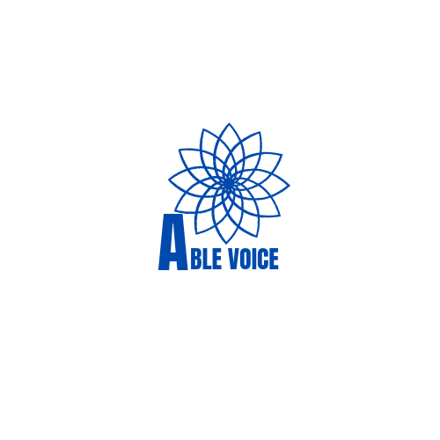 ABLE VOICE

**MOTTO:** Raising and speaking for the Children with disability

**Email:** [**ablevoice2021@gmail.com**](mailto:ablevoice2021@gmail.com)

**Phone Number: +234 8131692654 || Oyo, Oyo State, Nigeria.**

**PROJECT DETAILS**

**THEY NEED HELP**

**Who are They?**

They are children whom the society has exiled, the forgotten! Children with disabilities are most times neglected by their parents and the society at large. The attitudes of individuals are grievous to these children leaving them with the fate of no hope.

In Oyo town, based on my personal experience which I might not be able to share with you here because of time restriction, Children with disability (blind, deaf, autistic, physically disabled children etc.) are not catered for. Little or no concerns are given by the society and parents about their health, education, welfare and wellness. In return, this action has effect and a bad consequence on their future.

This is why I take my stand to fill the gap.

**Who am I?**

I'm sorry I didn't introduce myself earlier.

I am **ABLE VOICE**, a Non-Governmental Organization that speaks for, and raises children with disabilities for a better future. The vision is to liberate these individuals from their shackles irrespective of their background and disability, to bring out their abilities so that they can be useful for themselves and become self reliant, independent and contribute integrally to the growth and development of the society and the nation at large.

Upon this baseline, I want to have my **MAIDEN PROJECT**, which I cannot do alone.

To a larger effect, your support would push this project further and contribute to the achievement of the objectives . My team are fully ready to launch out but we are being restricted due to financial incapability. You are the last hope and I know you will support me on this.

**Quickly, what do I want to do exactly?**

1. I am to carry out a field survey in market places and streets to see children with disabilities and their parents/guardians/caregivers, this will help to sample out those who need helps. Notably, this will not be done single -handedly but a joint work with specialists in respective fields.

2. I am to organize campaigns, seminars and awareness for the society about disabilities and children with disabilities. In which I strongly believe that this will change the status quo of the society in how they perceive these children and as a result, the campaign will positively influence their attitudes.

3. After a careful analysis on the data collected from the field survey. This project will use two major tools to help the selected children who would be the beneficiaries. The tools are;

**a. Educational approach:** Children with disabilities who are educable would be supported educationally, such that their school uniform, sandal, notebooks and textbooks, tuition fees and any related fees would be catered for.

**b. Vocational Approach:** There are some categories of children with disabilities who might not be fit for schooling, these individuals can hence be trainable. I would suit them in for vocational training, such as shoe making, bag making, tie and dye , and any other craft that could suit their condition . For these children, all training fees and related fees would be catered for.

**DURATION:** The duration for this project shall be a week. But consequently, there shall be follow up until the success of the selected children is guaranteed.

**PRESENT BUDGET:** one million naira.

Although, the present estimated budget for this project is 1million naira (which we would still be needing more), but we are persuaded that your contribution will go a long way.

In a nutshell, in the course of the project, incentives shall be given to both the children and their parents. Can you now see that I cannot do it alone, that is why I am clamouring for your help, that you should please assist in your great capacity. Nothing is small and nothing is too big.

**PROJECT DATE:** July, 2022.

To support this project, kindly refer to the account details below.

**Account Number:** 0246478698

**Account Name:** Oyedemi Oluwatobi Tomiwa

**Bank Name:** Wema Bank

For enquiry, please kindly contact;

**Miss. Kenny**, 08108348674 - ABLE VOICE, support group team lead

**Mr. Deji**, 08164989869 - ABLE VOICE, Project Manager

**Mr. Oluwatobi,** 08154382116 (WhatsApp), 08131692654 (Call)- ABLE VOICE, Director.

**Email:** ablevoice2021@gmail.com

**Facebook:** ABLE VOICE

The project can be achieved through your maximum contributions and humanity will be benefitted. I ***SHALL SURELY REPORT TO YOU ON THE PROGRESS OF THE PROJECT BECAUSE I AM ACCOUNTABLE TO YOU.***

Thank you for your time and great support in anticipation.

Regards,

**ABLE VOICE**